Jaden Castle

Dr. Retterer

ECCS 1421

1/22/2017

NetBeans helped when writing the code as it generates the basics of it. This seems like it will be a very useful feature because to display “Hello, World!” only one line of code was needed to get it running.

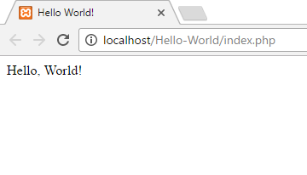Then the title of the page was also fairly easy to change as NetBeans had generated an area to place the title. The part that took the longest when working on this assignment were the downloads of xampp and NetBeans. Xampp also seems fairly easy to use as it once installed it only requires a few buttons to start and stop servers.